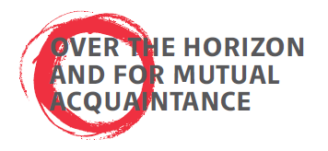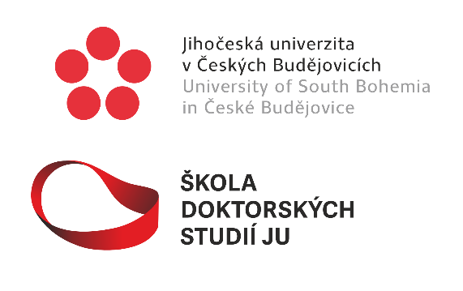

4th USB Conference of Doctoral Candidates
December 3 - 4, 2025
University Aula

The USB School of Doctoral Studies proudly announces the 4th USB Conference of Doctoral Candidates, scheduled to take place on December 3-4, 2025, in our new University Aula. About 50-60 doctoral candidates from all faculties gathered and presented their research to their fellows at the previous three conferences. On all occasions, the conference atmosphere was unexpectedly warm and friendly, and we, as the organizers, hope it will continue to be so. We invite you to be part of its next chapter and look forward to seeing you at our 2025 conference!
The idea of this conference stands on three pillars:
- Strengthening the social integration of doctoral candidates at USB beyond fields and faculties.
- Unity of science and mutual respect of all fields and all researchers as the basis for the fruitful future of research.
- A need for interdisciplinarity in solving global challenges.
The aim of this conference is to promote values aligned with these pillars from the outset of a research career.
Contributions: There are no restrictions regarding the topics of individual contributions. Given the conference aim, they should be comprehensible (at least for the most part) to an audience from different disciplines. A brief explanation of the research topic, the methods used, and possibly what (partial) results have already been achieved, will be awesome. Where possible, the emphasis on societal impact and interdisciplinarity is appropriate, but it should follow naturally. Contributions can take the form of both presentations and posters. The length of individual presentations is planned to be 15 minutes, including a short discussion.
Further information: Attendance at the conference is free. Attendance at the conference is voluntary. The conference language is English. The conference structure is standard, consisting of presentation blocks separated by coffee breaks and a poster session. At the end of the second conference day, a social evening will take place, during which the best presentations and posters will also be recognized. And it will be you, the doctoral candidates, who will chair individual sessions and vote for the winners.
Major dates:
Conference applications on the attached Application Form: until 25 November 2025
Conference program announcement: until 30 November 2025
For any further information, please email lberec@prf.jcu.cz (Luděk Berec, main organizer, vice-rector for science and research).
Webpage with announcement and Application Form: https://www.jcu.cz/cz/studium/skola-doktorskych-studii-jihoceske-univerzity/student

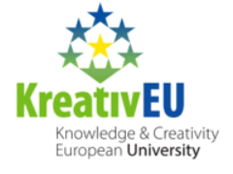
Since the University of South Bohemia is a proud member of the KreativEU consortium. This consortium of 11 European universities has agreed on a common goal of establishing a fully European University, which places the creative potential derived from Europe’s cultural heritage at the heart of its teaching, research, and knowledge transfer activities. We therefore invite doctoral candidates from all our KreativeEU university partners to our conference, with the link for remote participation to be sent shortly before the conference begins. Remote participation will only be allowed for listening, not for presenting.

